The Design and Research of an Oral Examination Management System Based on Node.js
Wei-na ZHU, Yan-song CUI and Dan-zhi WANG
Beijing University of Posts and Telecommunications, Beijing, China
Keywords: Examination management, Node.js, NW.js, Socket.IO, WebSocket.
Abstract. This paper aims to provide a practical approach to developing PC desktop applications using web technologies. The management system selects NW.js as the basis and then uses Node.js, web technologies to develop. It also uses Socket.IO to achieve the two-way instant communication. In terms of technology, the development method proposed in this paper can solve the disadvantages of traditional PC desktop applications, including the inaesthetic user interface, the poor portability, and so on. And from the perspective of effect, the management system can reduce financial resources, manpower and space that the school spends on oral examination. This paper applies web technologies
to the development of PC desktop applications innovatively.

Introduction
With the popularization of quality-oriented education, the importance of oral education in primary and secondary education is becoming more and more obvious. In order to improve the quality of oral teaching, online oral examination system came into being. This paper mainly introduces the management system of the online oral examination system. The functions of the management system mainly include the distribution of papers, the upload of answer files, and the monitoring of examination progress. The management system abandoned the development model of previous PC desktop applications, instead of using Web Technology for development.

System Structure
The oral examination management system is a part of the online oral examination system,which plays an important role in data connectivity. The online oral examination system includes exam clients, an examination management system, a supporting platform and a cloud storage platform, as shown in figure 1.
Figure 1. Online oral examination system structure diagram.

In the online oral examination system, the supporting platform and the cloud storage platform are in the WAN, the exam clients are in the LAN, and the exam clients cannot access the WAN directly. In the LAN, the management system is equivalent to a server for the exam clients. The management system is a bridge between the exam clients and the WAN. The management system requests the examination paper from the supporting platform firstly, and then broadcasts the paper to the exam clients. The management system can obtain progress information and answer files of all the exam clients instantly. After the examination, the management system will upload all answer files to the cloud storage platform. The detailed flow chart is shown in figure 2.
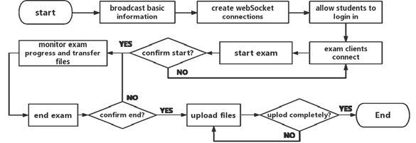
Figure 2. The flow chart of the management system.

Key Technology
With the development of Internet technology, users of desktop applications pay more and more attention to the aesthetics and interactivity of the program interface. Meanwhile, the management system plays the role of a server in comparison with the exam clients, and it requires the function of file storage, file transmission and so on. Therefore, the key technologies of this management system includes three main aspects: user interface, server design and file processing.

User Interface
This management system focuses on the beauty of the style and the convenience of the operation. In order to realize these purposes, this management system adopts NW.js and Vue.js in the user interface.
NW.js runs based on Chromium and Node.js. It supports developing applications using HTML5, CSS3, and JS. Moreover, it also fully supports Node.js APIs and all the third party modules. For lightweight applications, its performance is also fine. With the help of NW.js, this management can be developed by web technology and packaged into desktop application by other tool easily.
Vue is a lightweight, progressive front-end development framework, it is designed for bottom-up application. Vue's core library focuses only on the view layer and it is not only easy to use, but also easy to integrate with third party libraries or existing projects. The data drive of Vue can avoid frequent DOM operations. When the exam clients’ progress changes, we only need to change the data, and Vue can refresh corresponding DOM elements automatically. Moreover, Vue.js also has the advantages of modularization and the componentization.

Server Design
In the LAN, the management system is a server relative to the exam clients. Considering the various data transmission between the management system and the exam clients, the UDP protocol, TCP protocol, WebSocket protocol and Socket.IO are applied in this management on the basis of Node.js.
Node.js. Node.js is a platform run on Chrome V8 to build fast, extensible web applications.Node.js uses an event-driven, non-blocking I/O model, which also makes data-intensive real-time applications across distributed devices lighter, more efficient and more perfect. In the case of high concurrent requests, the server built by asynchronous non-blocking Node.js has shorter response time and higher throughput than the application built by synchronous blocking language PHP. Therefore, the management system adopts Node.js to further realize multi-user real-time monitoring.[1]

Transport Protocols and Socket.IO. The TCP protocol is a connection-oriented, reliable transport layer protocol. It uses the triple handshake protocol to establish the connection. UDP is also a transport layer protocol. Different from TCP protocol, UDP protocol is connectionless and less reliable. WebSocket protocol is a new frame protocol on HTML5. The essence of WebSocket protocol is to shake hands through HTTP protocol and then create a TCP connection to exchange data. After that, the server and the browser communicate in real time through this TCP connection.[3]This management broadcast. system uses webSocket to achieve two-way communications and uses UDP to Socket.IO is an extension module of Node.js. It simplifies WebSocket and unifies the API of communication. It provides both components of the server and the client, enabling the server and the client to send events, send data, communicate with each other, and even support the server to broadcast the data to all clients.Socket.IO will automatically select the best way to implement the real-time collaborative network application according to the browser.

File Processing

This management system involves of lots of file processing. The fs module of Node.js provides interfaces for file operations. We can get information of files, read and write files, create directories and files, delete directories and files, and so on. The fs module provides both synchronous and asynchronous methods for all functions. Since asynchronous mode does not block program execution, it is generally recommended to use asynchronous methods to achieve the desired function .But it is more appropriate to use synchronous methods for recurrence.

Function Realization

The implementation of the management system mainly involves four aspects: construction of user interface, server implementation, implementation of file processing

Construction of User Interface

The management system uses NW.js and Vue.js to construct user interface. It is recommended to use NPM to install NW.js. For a project based on NW.js, an entry HTML file and a configuration file called package. json are necessary in the directory structure. And two attributes called ’name’ and ‘main’ respectively must be included in the file called package. json. The attribute called ‘name’ refers to the program name and the attribute called ‘main’ refers to the entry HTML file. In addition, package. json can be used to configure window information, module dependencies and so on.Vue.js can be directly downloaded on the official website and we can use it through the HTML tag called script when building a small application; In the construction of large applications, it is recommended to download Vue.js by NPM in order to achieve modularization and componentization. The main user interfaces of this management system are shown in figure 3:

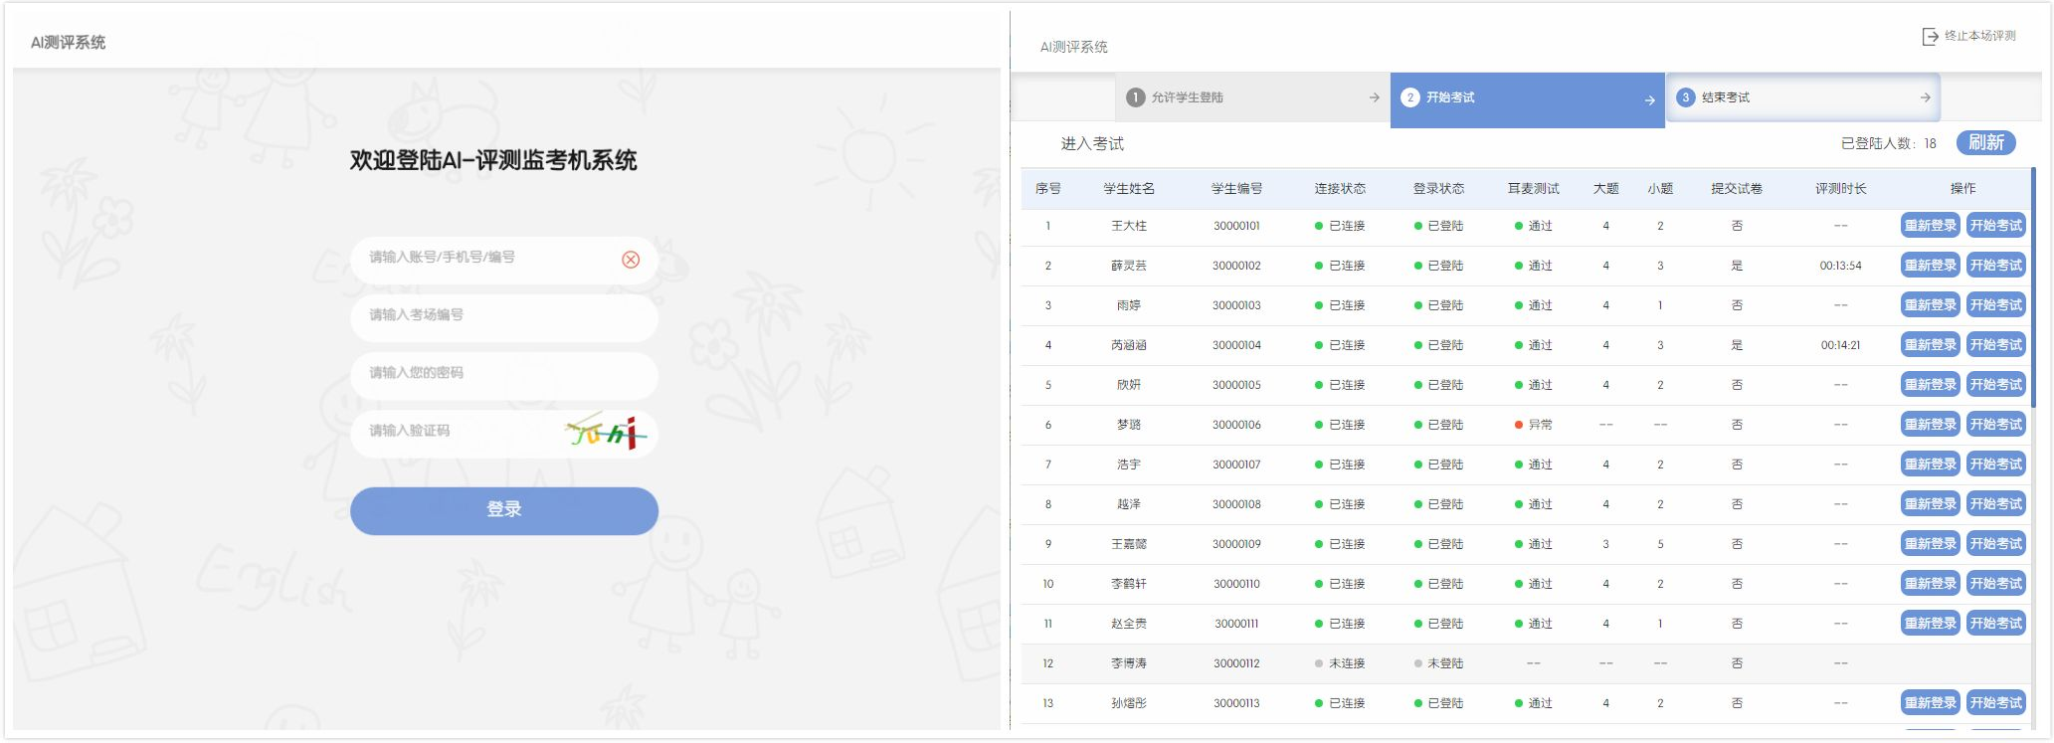
Figure 3. The main pages of this management system.

Server Implementation

The management system starts to look for the available port when it starts, then the management system broadcasts the IP and port number to the exam clients in the LAN through the UDP protocol. After the invigilator logs in, this management system creates a HTTP server and upgrades HTTP protocol to WebSocket protocol through Socket.IO. Then, the exam clients connect the management system to build WebSocket communication.We should install the dgram module, the http module and the socket.IO module of Node.js with NPM. The dgram module encapsulates some UDP interfaces, and the Socket.IO module provides the simplified WebSocket interfaces. These modules are used in JavaScript as follows:
var http = require('http');
var dgram = require("dgram");
var socket = dgram.createSocket("udp4");
var server = http.createServer(function (req,res){
...
}).listen(port);
var io = require('socket.io').listen(server);

Implementation of File Processing

The management system uses fs module of the Node.js to realize file processing. To use the fs module, you need to install the fs module with NPM firstly, and then load it through the statement of var fs = required(‘fs’).

In order to prevent the management system from occupying lots of disk space after a large number of examinations, the storage directory is checked and the folders created one month ago are found to delete when the system is started. Although the asynchronous mode of fs module is recommend to use, synchronization method is better to iterate. And the code of this function is run independently, so the performance will not be affected. When realizing this function, the method called fs.statSync is used to view the attributes of files or folders, the method called fs.unlinkSync is used to delete files, and the method called fs.rmdirSync is used to delete empty folders.

In addition, fs.createWriteStream is used to write the requested raw data into the required file when the management system downloads audio and pictures from the supporting platform. When reading and writing log files, the methods of fs.readFile, fs.writeFile and fs.appendFile are used.

System Testing

The system testing of this management system mainly includes two aspects: function test and performance test, and the concrete test contents are shown in Table 1
Table 1. Test Content
Function Test | Performance Test
distribute paper to exam clients | high concurrent connection requests
obtain progress of exam clients | response time for primary events
collect answer files of exam files | CPU occupancy and memory occupancy

Function Test

The management system is run on the Windows10 operating system, and the TCP/UDP Performance Test Tool is used to simulate the connection of several exam clients on the computer of a dual-core 4G memory and Windows XP system at the same time. And additional scripts are written to make the test tool compatible with Socket.IO. The number of connections and the event of communication are set in the TCP/UDP Performance Test Tool according to Table 2.
Table 2. The number of connections and the event of communication
connections | Event
connections | event name | event meaning | infomation sent to clients | Information received from clients
500 | stu_confirm | distribute paper | true | Json string of the paper
1000 | ifSubmit | obtain progress | true | true
5000 | file_to_teacher | Collect files | the buffer of a MP3 file | true
Nine tests were carried out in the function test according to the principle of single variable, and 10 times for each test. Finally, the nine average was calculated respectively. The results of function test are shown in figure 5.It can be seen from figure 5 that the success rate is still over 99.9% when the number of concurrent connection requests rises to 5000.So,the performance of the management system is fairly good, and the error rate is very low.
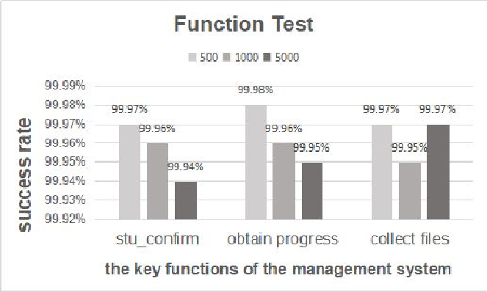
Figure 5. The result of the function test

Performance Test

The function of file transmission between exam clients and the management system costs the most transmission quantity in all of the functions. So, it is selected to test the response time. The exam client records a time stamp of sending the file, and then the management system records another time stamp after receiving the file successfully. The difference between the two time stamps is the response time. The results of 1000 tests are shown in figure 6.The average of the response time is 39.1ms,and the other functions require shorter response time.

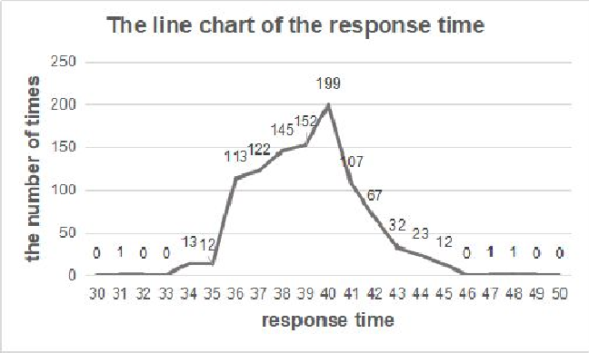

Figure 6. The line chart of response time

In order to test the single-point full load CPU occupancy and memory occupancy of the management system, the management system is run on different computers as the single application. The result can been seen from the task manager. Repeat the test 10 times and calculate the average on each computer. The results are shown in Table 3.
Table 3. Occupancy rate of CPU and occupancy rate of memory in different computers
Information of a computer |  |  | Result
system | CPU | memory | CPU occupancy rate | memory occupancy rate
Windows XP | dual core 2.5GHz | 2GB | 15.8% | 13.1%
Windows XP | dual core 2.8GHz | 4GB | 13.2% | 8.3%
Windows 7 | dual core 2.8GHz | 4GB | 12.8% | 7.9%
Windows 10 | dual core 2.5GHz | 6GB | 14.5% | 4.2%
Windows 10 | Quad-core 2.5GHz | 6GB | 9.5% | 3.8%

It can be seen from Table 3 that even if this management system runs on a low level computer, the CPU occupancy rate and memory occupancy rate are still lower than 20%.

We can draw conclusions that this management system has good performance and does not require much for the computers of school from the above three performance tests.

Summary

This paper introduces an oral examination management system, which is based on Node.js and uses web technology to develop. After testing, the management system can make at least 5000 students conduct oral examination simultaneously, and it can realize the function of distributing papers, monitoring the progress of the exam clients in real time ,collecting answers and uploading files. This management system solves the problem that the implementation of oral English examination consumes lots of manpower, material resources and time, so that English teachers can concentrate on teaching and examination content. At the same time, the system has the advantages of low development difficulty, low cost, cross-platform, concise user interface and friendly interactive operation. In general, the management system has a wide range of applications.

References

[1] Feng Fang, Mei-Feng Gao. Mobile video surveillance system based on Node.js [J]. Computer Systems & Applications, 2017, 26(10).

[2] Sen-Quan Deng, Hai-BoYang. The practice of realizing Node.js application by Promise [J]. Computer Systems & Applications, 2017, 26(4): 218-223.

[3] Jia-Hao Qin. Research and performance analysis of Instant communication based on WebSocket [J]. Mobile Communications, 2017, 41(12): 44-48.

[4] Yi Zhang. Research and implementation of Instant communication system based on WebSocket [J]. Computer Engineering & Software, 2015, 36(3): 89-94.

[5] Guang-Wen Li. Design and implementation of Interactive Teaching Instant feedback system based on Socket.IO[J]. China Modern Educational Equipment, 2012(18): 10-12.

[6] Chaniotis I.K., Kyriakou K.I .D, Tselikas N.D. Is Node.js a viable option for building modern web applications? A performance evaluation study [M]. Springer-Verlag New York, Inc. 2015.

[7] Kim K, Lee K. Real-time processing of spatial attribute information for mobile web based on standard web framework and HTML5 [J]. Spatial Information Research, 2016, 24(2):93-101.

[8] Heinrich M, Gaedke M. WebSoDa: A Tailored Data Binding Framework for Web Programmers Leveraging the WebSocket Protocol and HTML5 Microdata [C]// International Conference on Web Engineering. Springer-Verlag, 2011: 387-390.

